**Homework 1 Part 2**

**Xiongming Dai**

1. 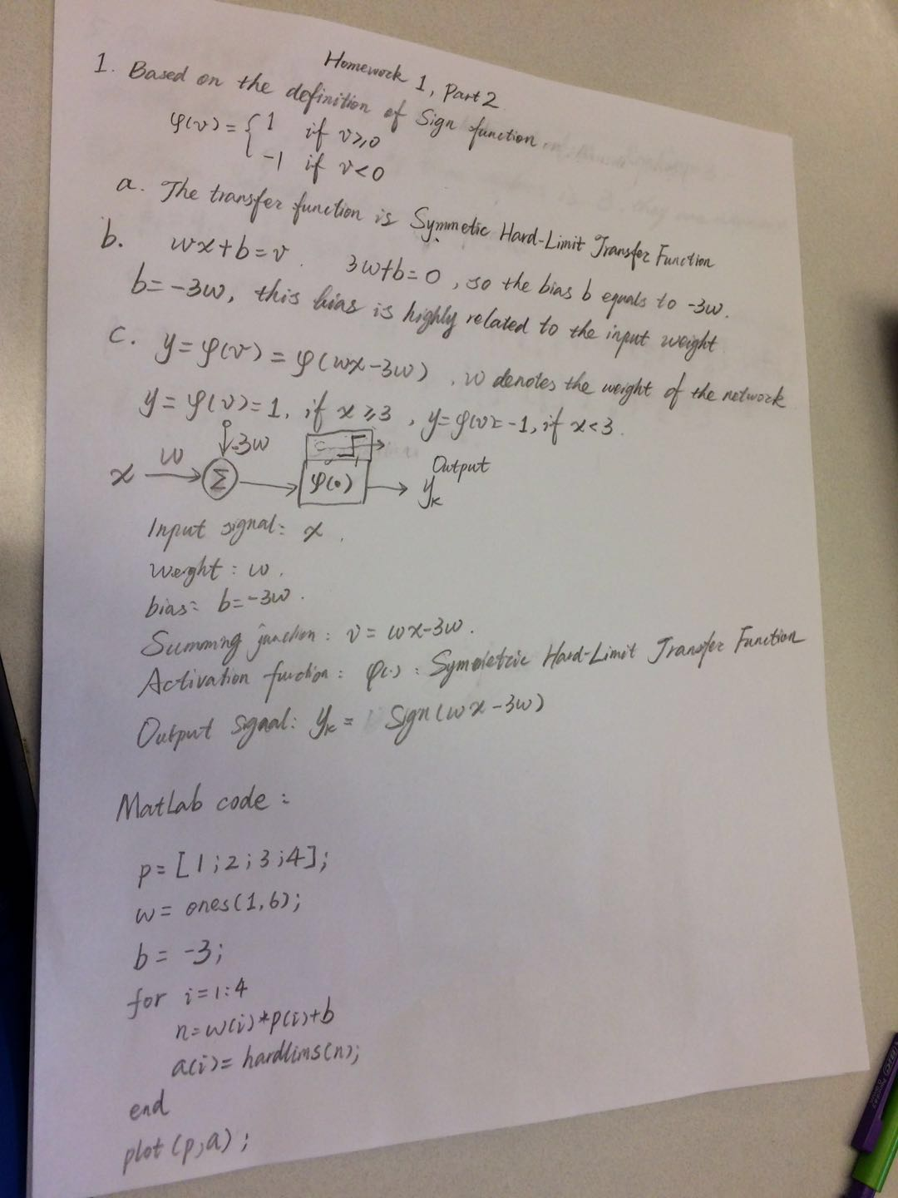
2. 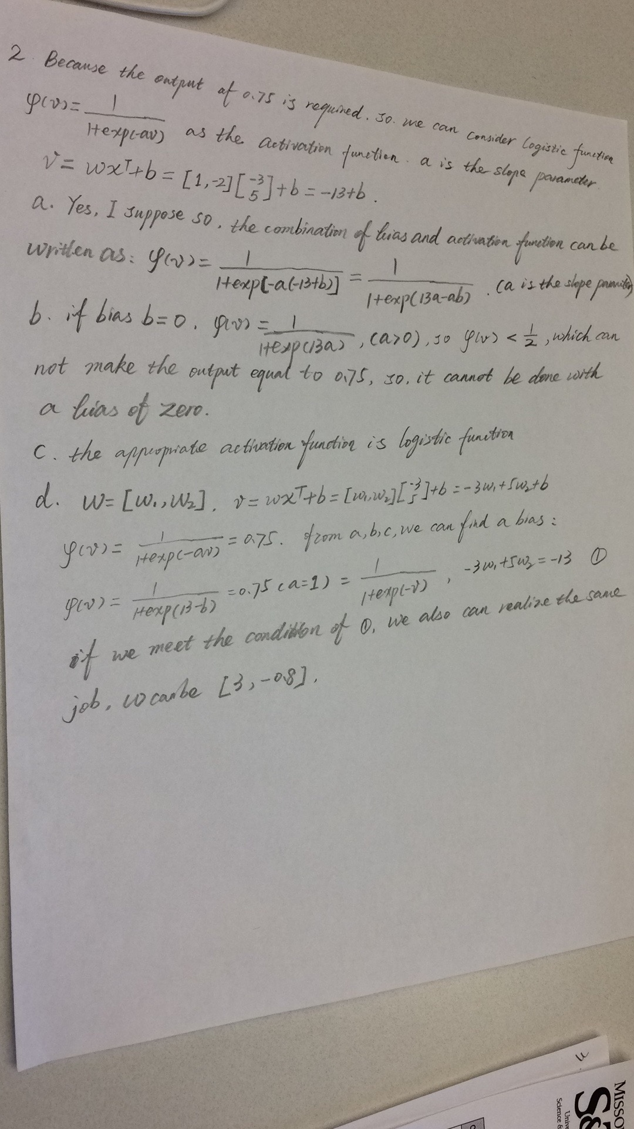
3. 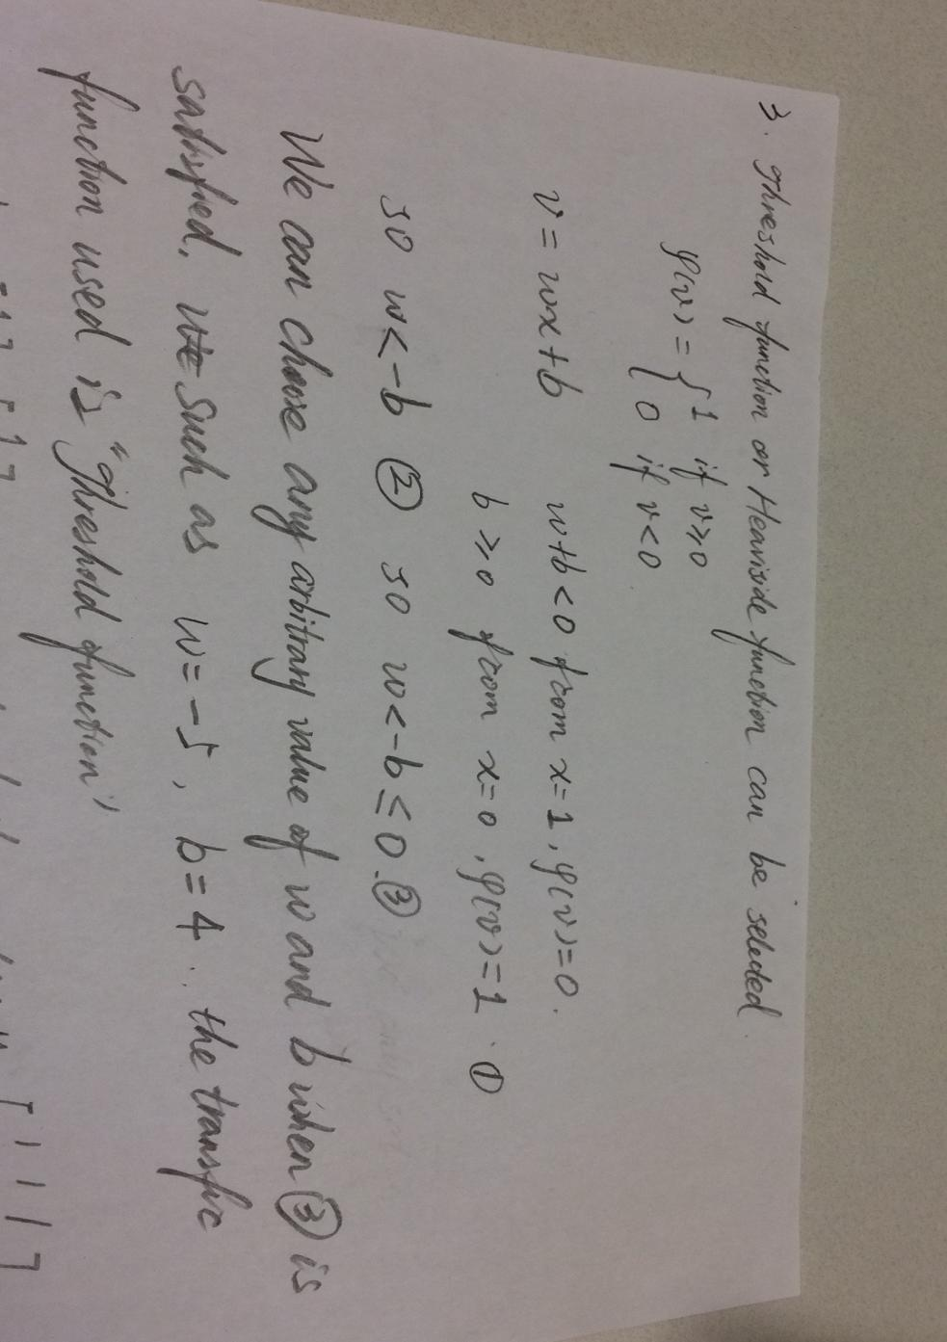

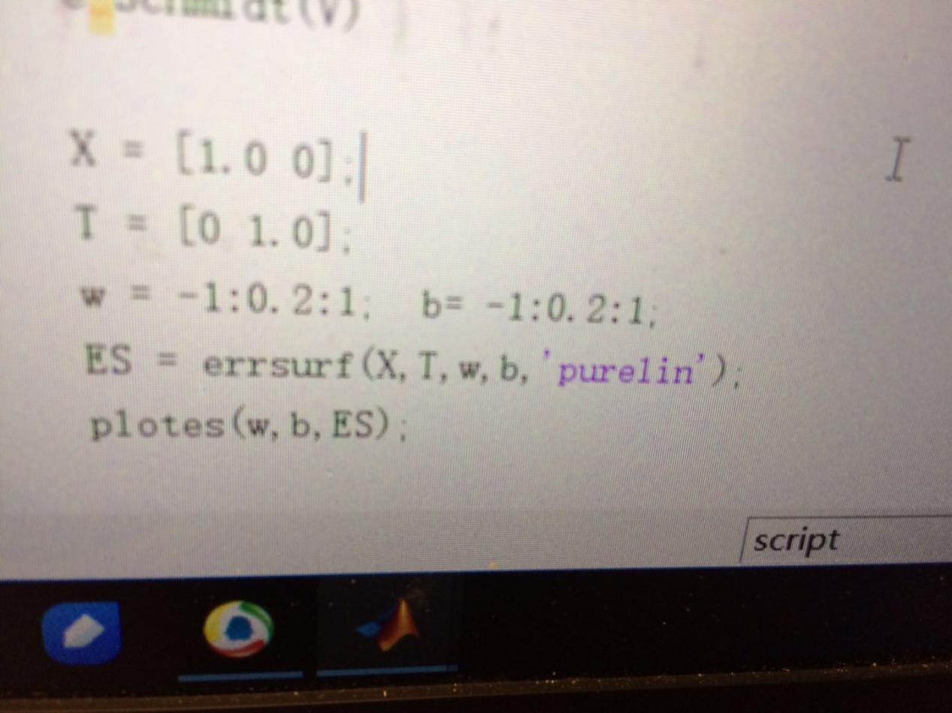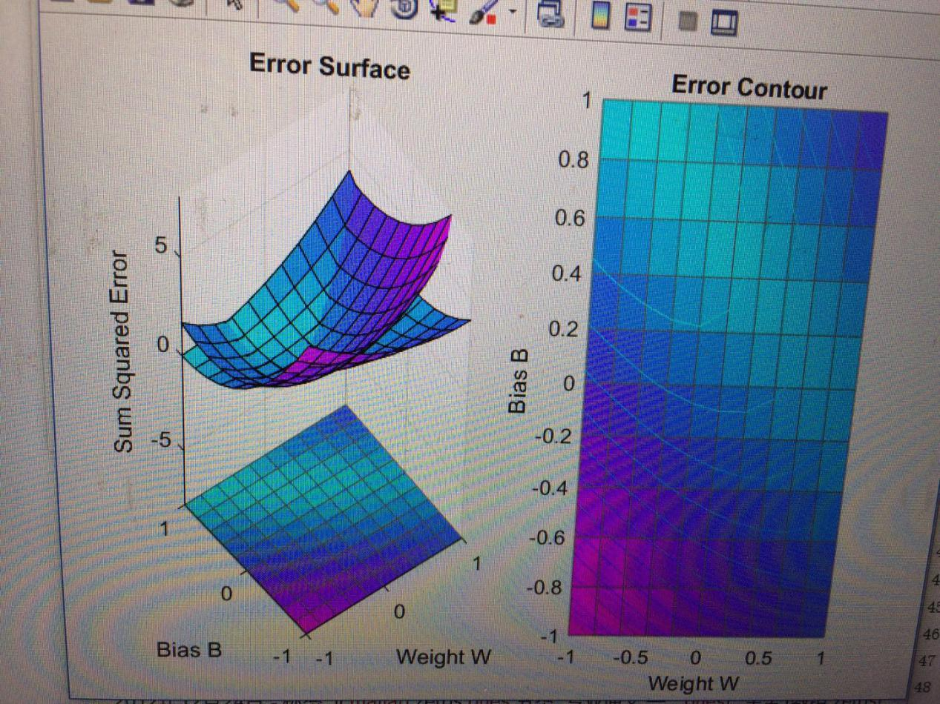

1. 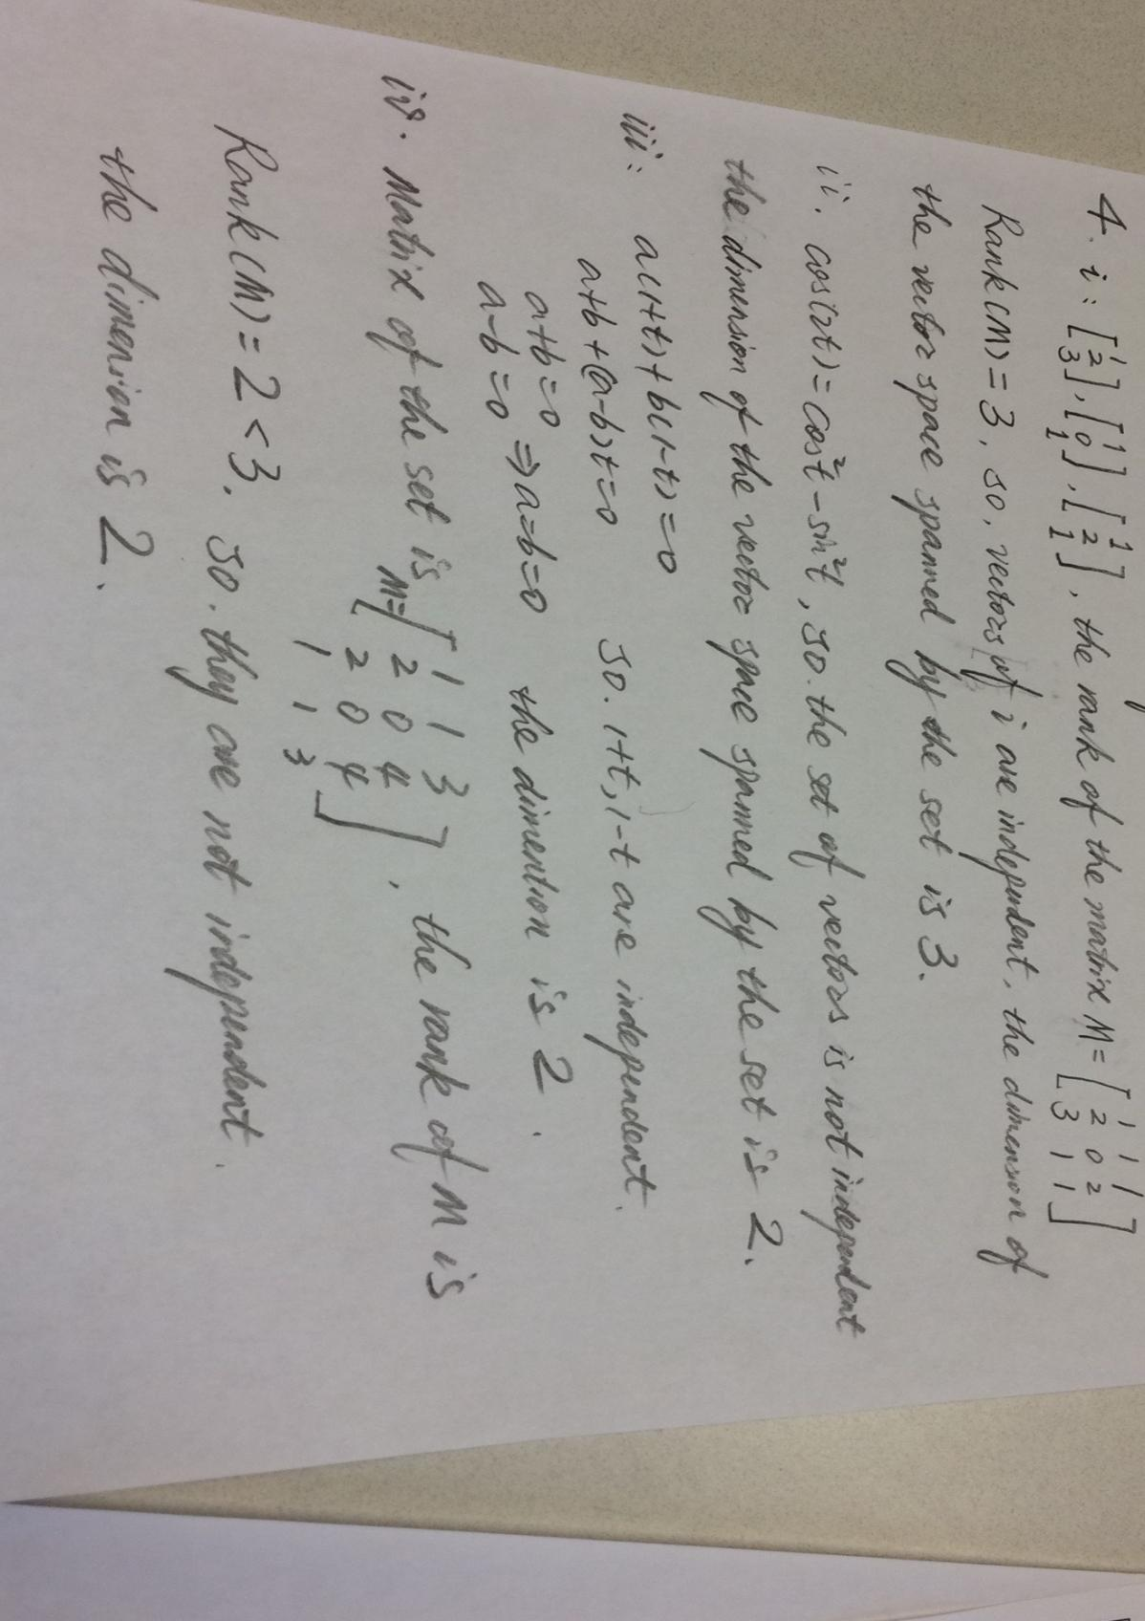

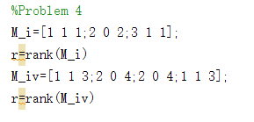

1. 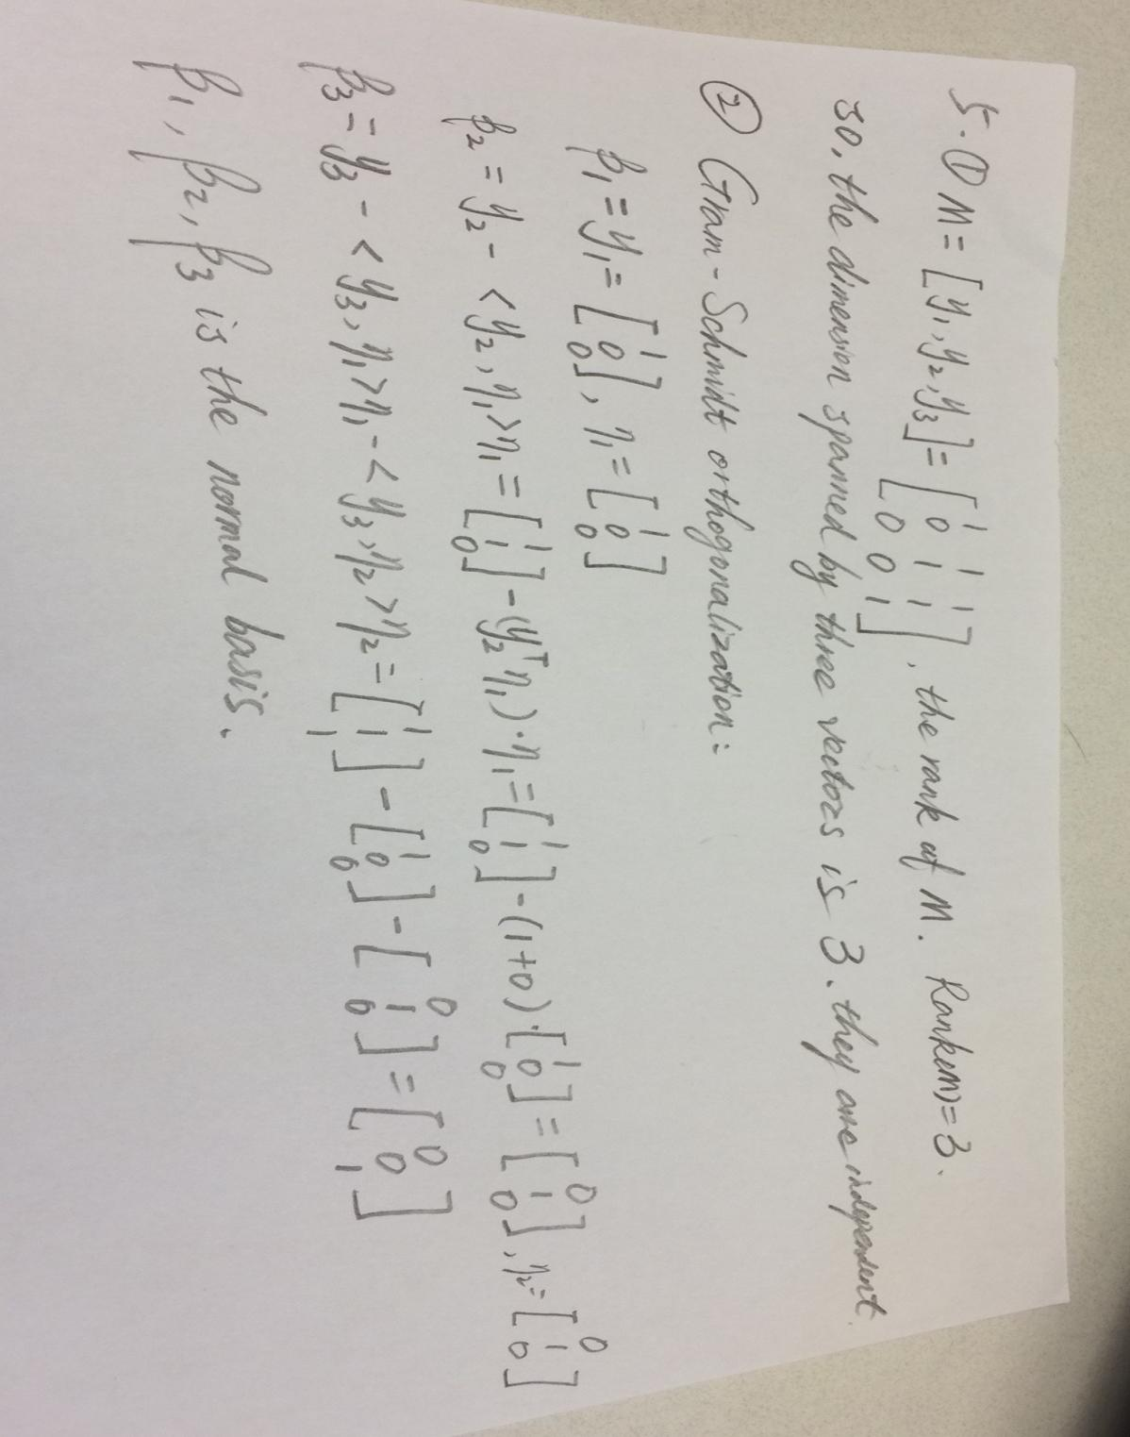

Matlab code:

function mat = Schmidt(v)

if(size(v,2)==1)

v=v';

mat = eye(size(v',1));

[a b ] =max(v);

mat(1,:)=v;

if(b~=1)

mat(b,:) = [1 zeros(1,size(mat,1)-1)];

end

else

mat = v;

end

for i=2:length(v)

mat(i-1,:)=mat(i-1,:)/sqrt(mat(i-1,:)*mat(i-1,:)');

b = mat(1:i-1,:)';

P = eye(size(b,1))-b*(b'*b)^-1*b';

mat(i,:) = mat(i,:)*P;

end

mat(end,:)=mat(end,:)/sqrt(mat(end,:)*mat(end,:)');

end

After running:

